Project Report

**1. INTRODUCTION**

1.1 Overview

This project aims to revolutionize supply chain management through data-driven insights using Qlik. By leveraging advanced analytics, the project focuses on optimizing logistics, forecasting, and inventory management to enhance operational efficiency and responsiveness.

1.2 Purpose

The purpose of this project is to utilize Qlik's advanced analytics to improve various aspects of supply chain management. By doing so, the project aims to:

- Optimize transportation routes and logistics.

- Enhance forecasting accuracy.

- Improve inventory management.

- Reduce operational costs and lead times.

- Facilitate quick decision-making in response to changes in demand.

1.3 Technical Architecture

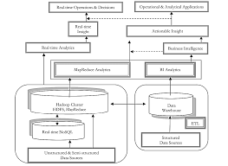

**2. Define Problem / Problem Understanding**

2.1 Specify the Business Problem

The primary business problem addressed in this project is the optimization of inventory levels and logistics in supply chain management. The goal is to reduce costs and prevent stockouts by using data-driven insights.

2.2 Business Requirements

To address the business problem, the following requirements were identified:

- Implement a robust data integration strategy.

- Utilize Qlik's visualization capabilities to create dynamic dashboards.

- Analyze historical logistics data to identify patterns and optimize routes.

- Implement real-time tracking and monitoring solutions.

- Use real-time analytics for quick decision-making in response to demand changes.

2.3 Literature Survey

A literature survey revealed a growing body of research focused on the role of data analytics in transforming supply chain processes. Studies highlight the effectiveness of advanced analytics tools like Qlik in enhancing visibility and decision-making. Research shows significant improvements in logistics optimization, forecasting accuracy, and inventory management efficiency through the use of data-driven insights.

3. Data Collection

3.1 Collect the Dataset

The dataset includes various columns such as:

- Type Count

- Days for Shipping (real)

- Days for Shipment (scheduled)

- Benefit per Item

- Sales per Customer

- Delivery Date

- Late Delivery Risk

- Category ID

- Customer Information (City, Country, Email, Name, Segment, State, Street, Zipcode)

- Market

- Order Information (City, Country, Customer ID, Date, Item Product Price, Profit Ratio, Quantity, Status, Zipcode)

- Product Information (Card ID, Category ID, Name, Image, Price)

3.2 Connect Data with Qlik Sense

The collected dataset was connected to Qlik Sense for further analysis and visualization. This involved importing the data into Qlik Sense and ensuring it was correctly formatted and structured for analysis.

4. Data Preparation

4.1 Prepare the Data for Visualization

Data preparation involved cleaning and transforming the data to make it suitable for visualization. This included:

- Removing irrelevant or missing data.

- Transforming the data into a format that can be easily visualized.

- Exploring the data to identify patterns and trends.

- Filtering the data to focus on specific subsets.

5. Data Visualizations

5.1 Visualizations

Several visualizations were created to analyze the performance and efficiency of the supply chain:

1. Total Items Placed by Country (Pie Chart)

- Dimensions: Customer Country

- Measures: SUM(Order item total)

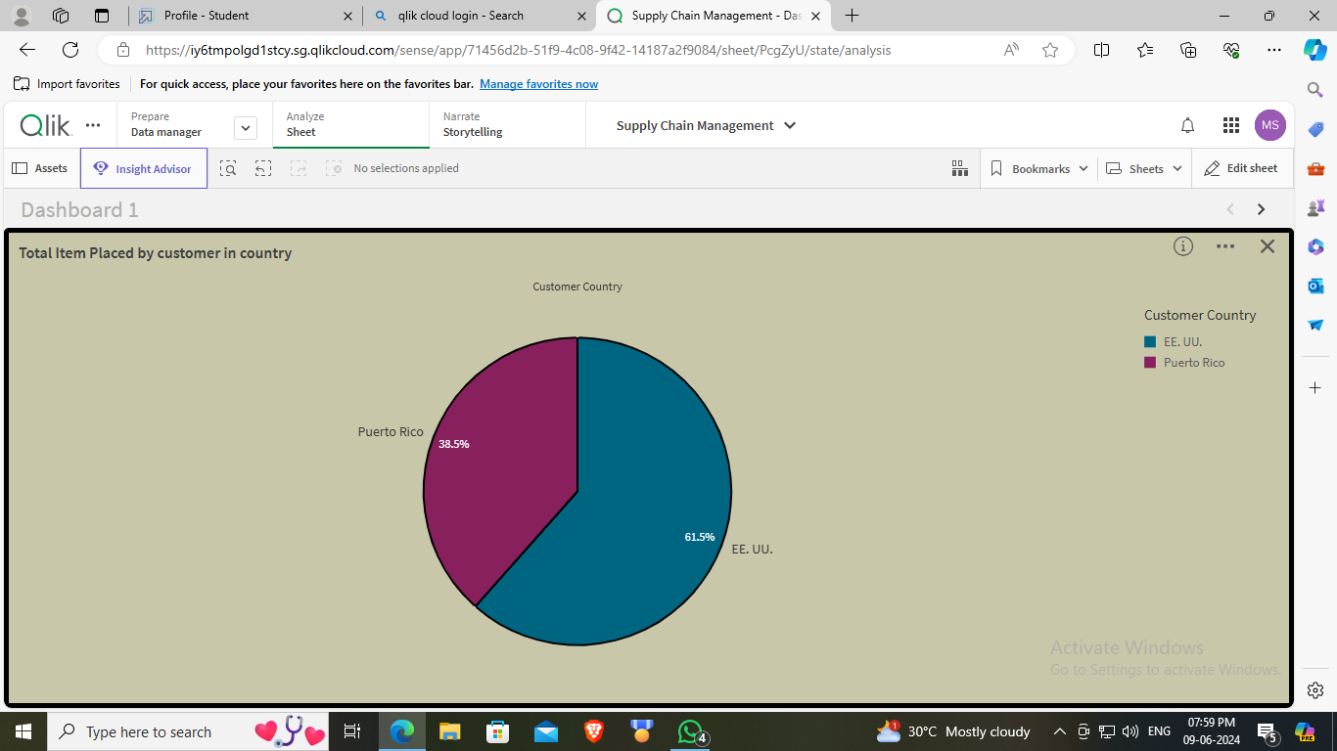

2. Total Items Placed by State (Bar Chart)

- Dimensions: Order States

- Measures: SUM(Order item total)

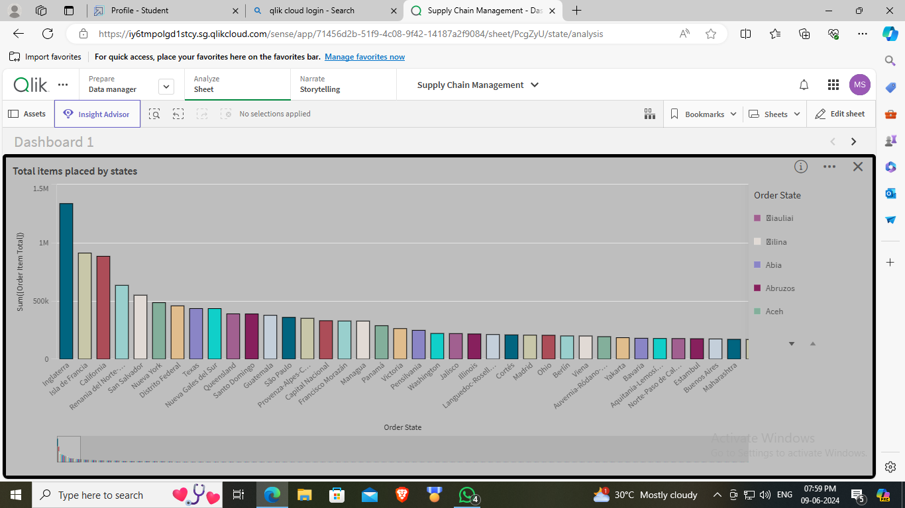

3. Global Profit Ratios (Donut Chart)

- Dimensions: Order Country

- Measures: SUM(Order profit per order)

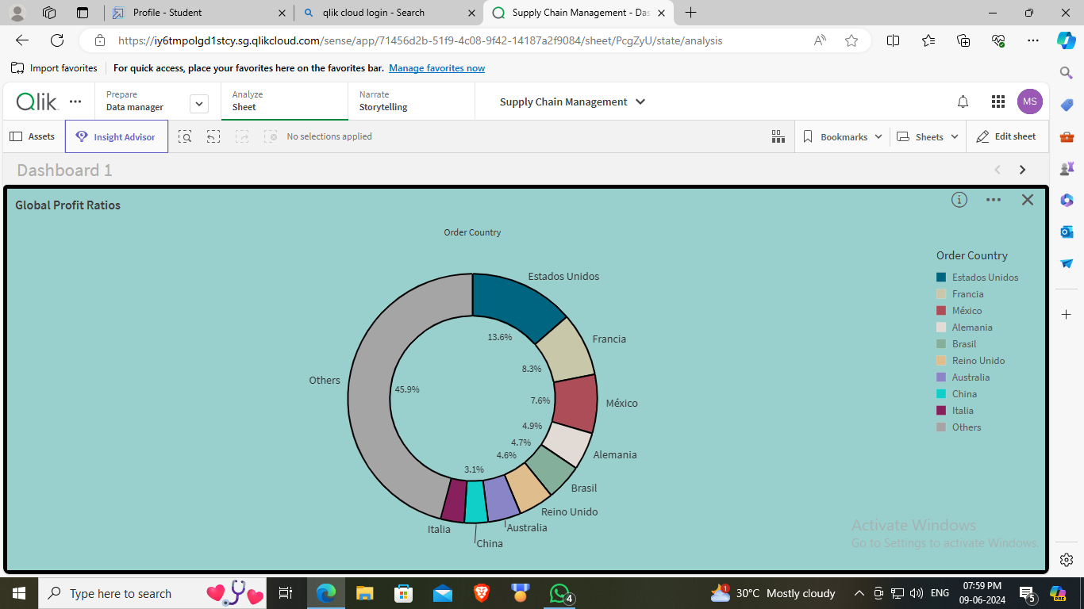

4. Customer Segment Analysis (Bar Chart)

- Dimensions: Customer Segment

- Measures: Count(Type)

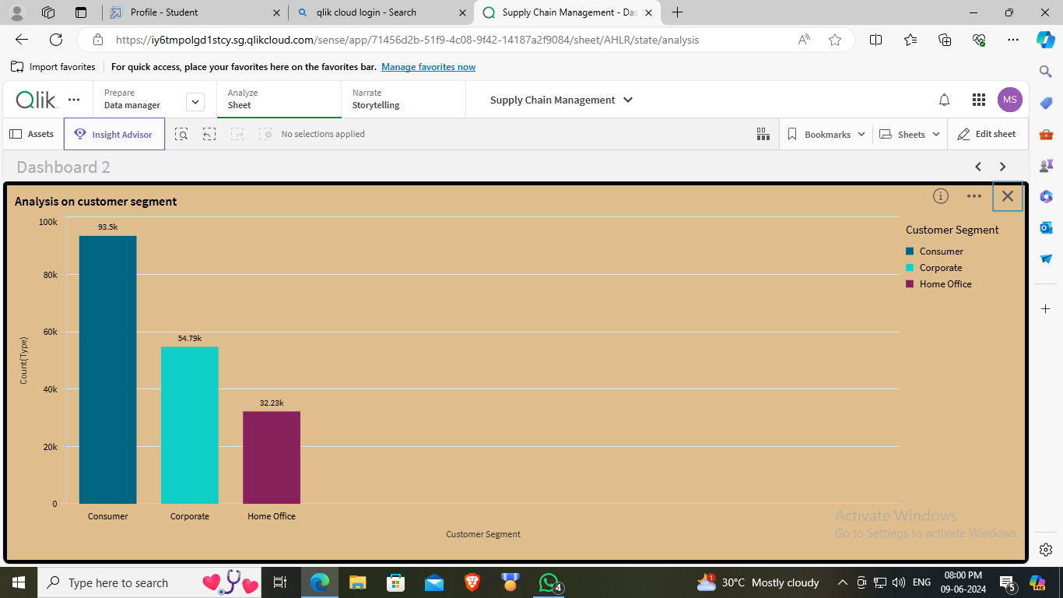

5. Mode of Payment (Bar Chart)

- Dimensions: Type

- Measures: Count(Type)

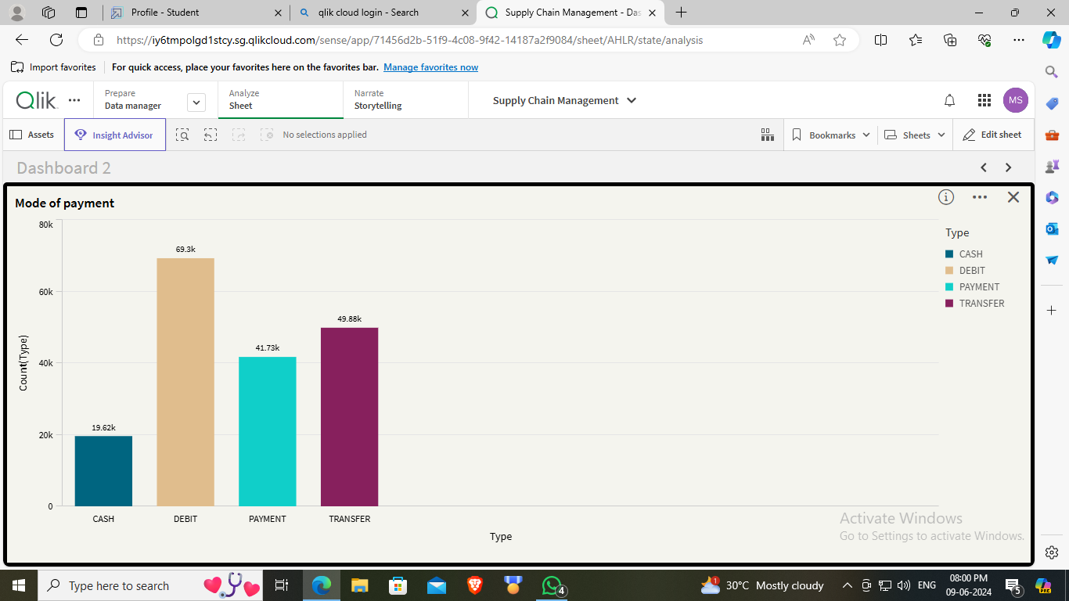

6. Customer Purchases by City (Bar Chart)

- Dimensions: Customer Country

- Measures: Count(Type)

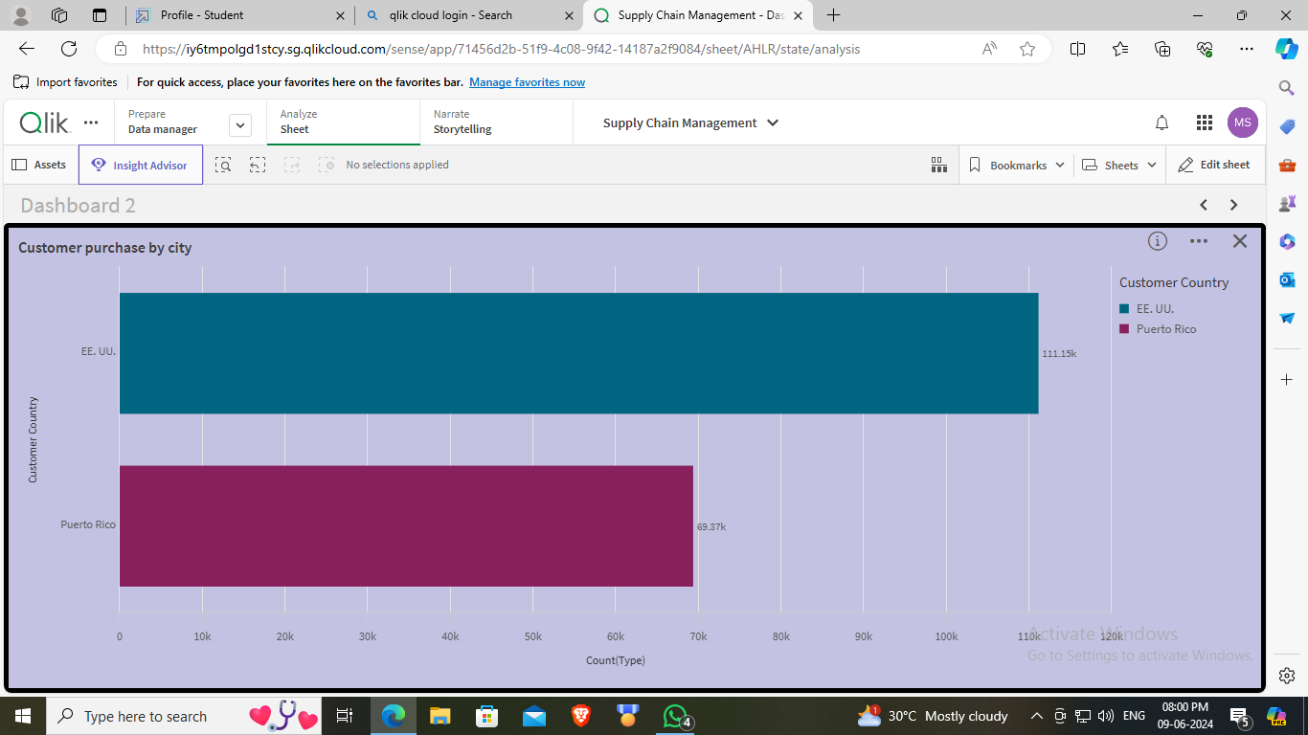

7. Order Delivery Status (Bar Chart)

- Dimensions: Delivery Status

- Measures: Count(Type)

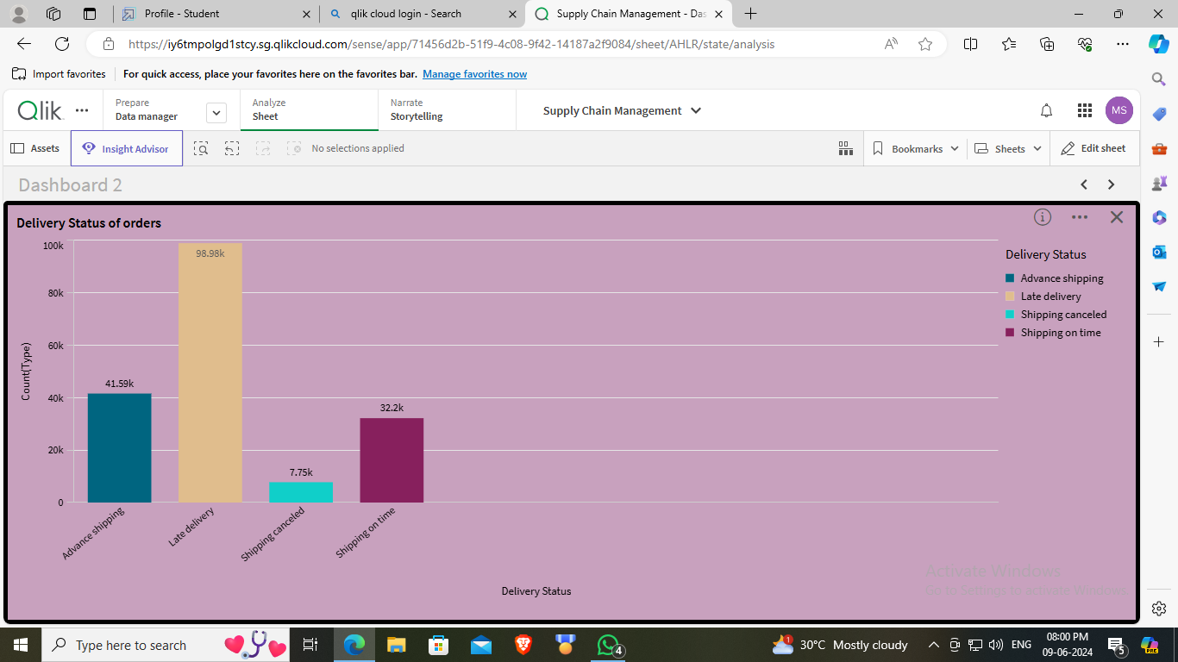

8. Benefit per Order Analysis (Scatter Plot)

- Dimensions: Benefits per Order

- Measures: SUM(Late Delivery Risk), Count(Type)

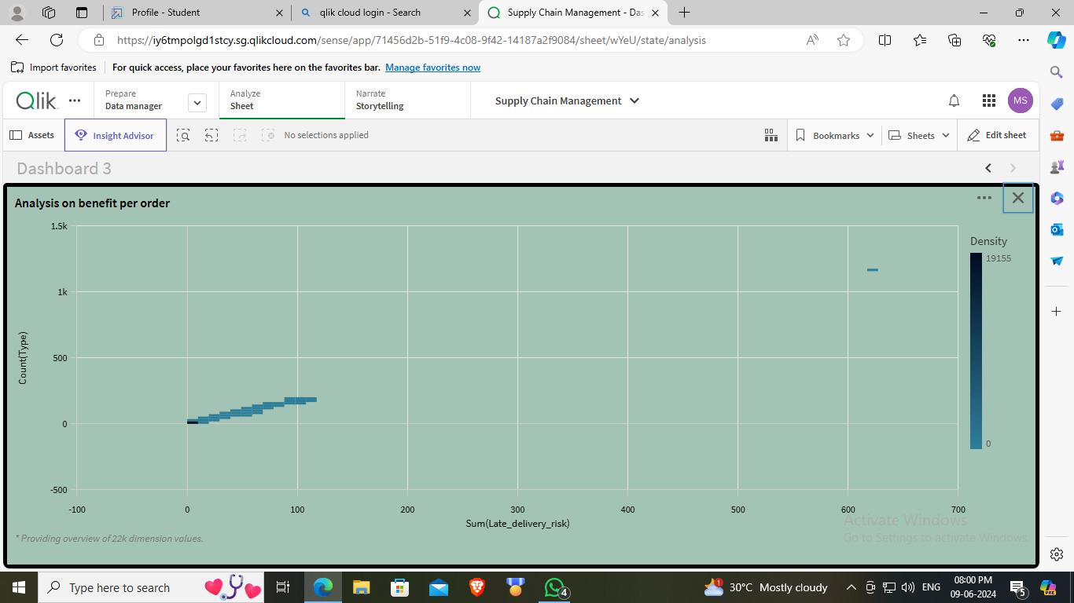

9. Profit Ratio Analysis (Histogram)

- Field: Order Item Profit Ratio

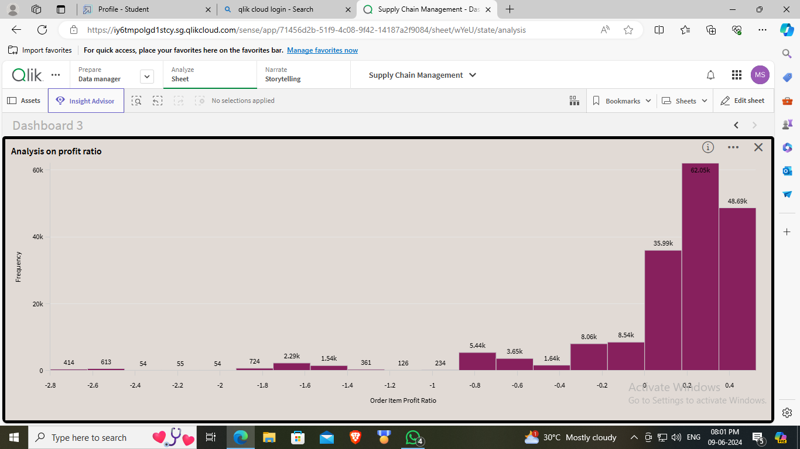

10. Market Analysis (Bar Chart)

- Dimensions: Market

- Measures: Count(Type)

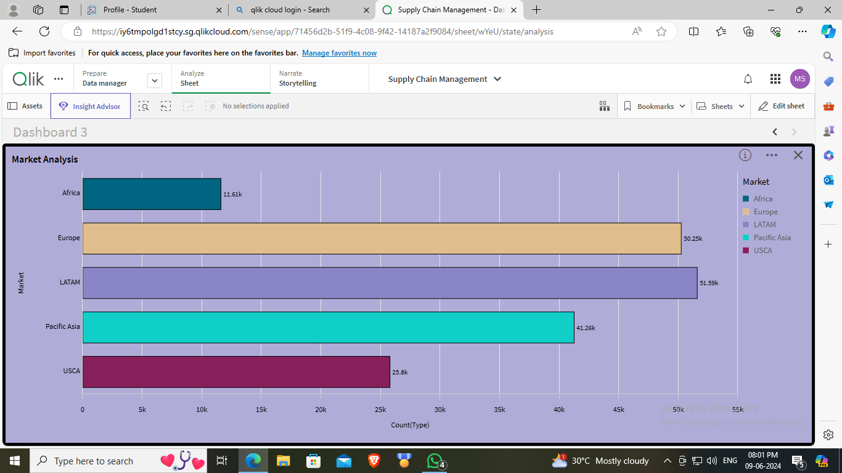

11. Order Region Analysis (Bar Chart)

- Dimensions: Order Region

- Measures: Count(Type)

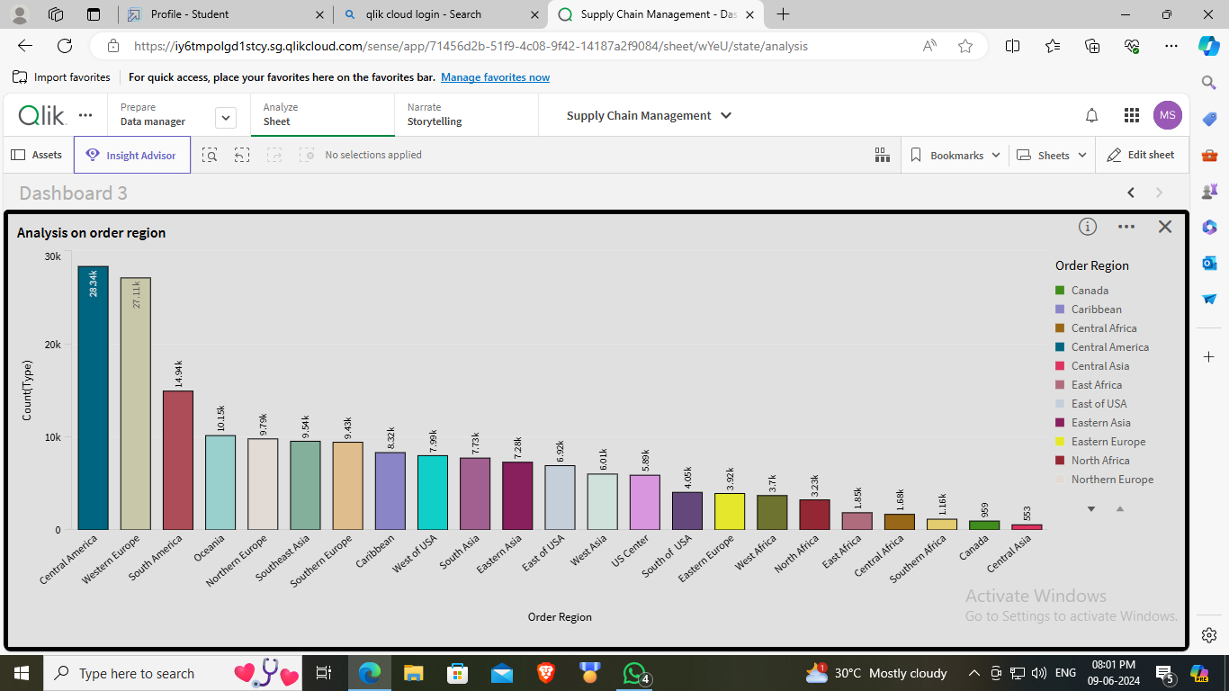

6. Dashboard

6.1 Responsive and Design of Dashboard

The dashboards were designed to be responsive and user-friendly. Key features include:

- Interactive elements that allow users to drill down into specific data points.

- Real-time updates to reflect the latest data.

- Intuitive layout for easy navigation and analysis.

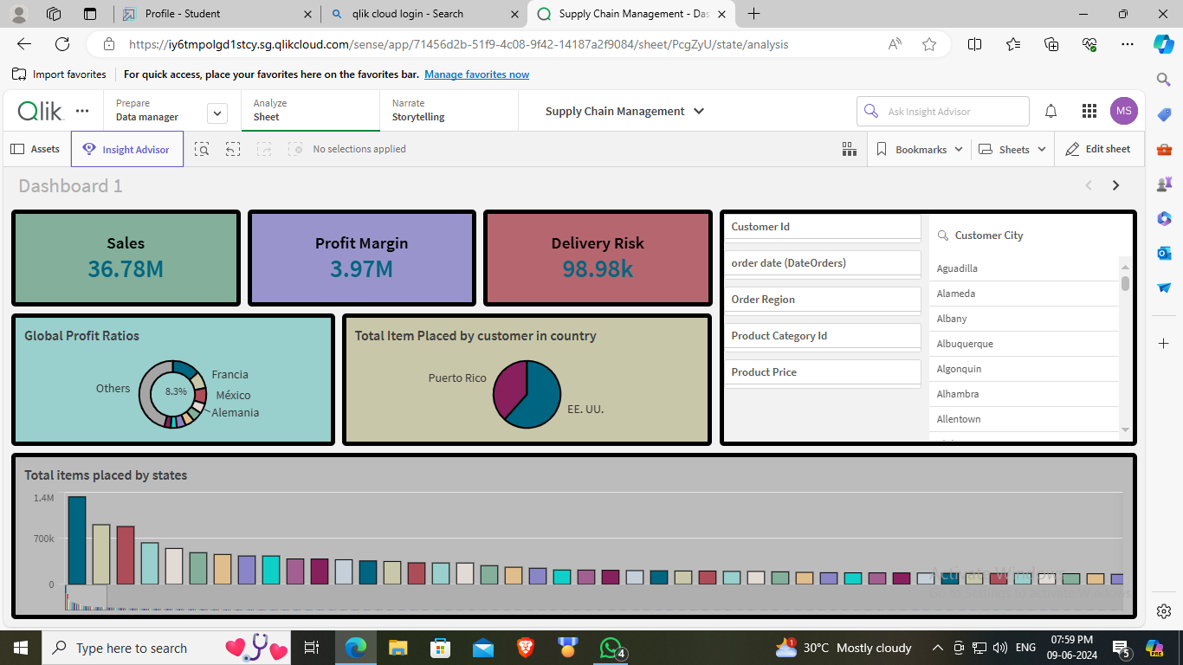

Dashboard 1

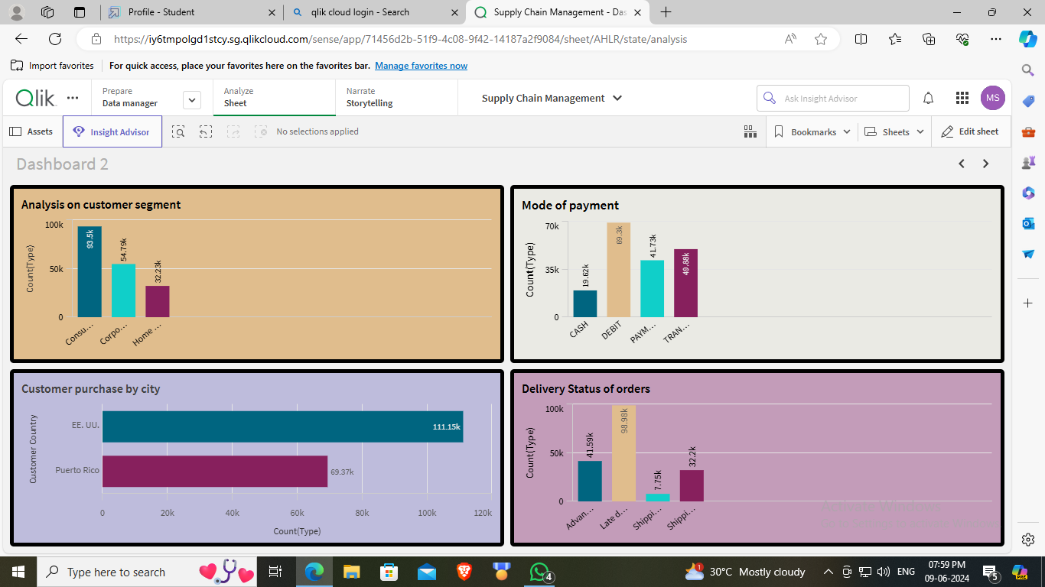

Dashboard 2

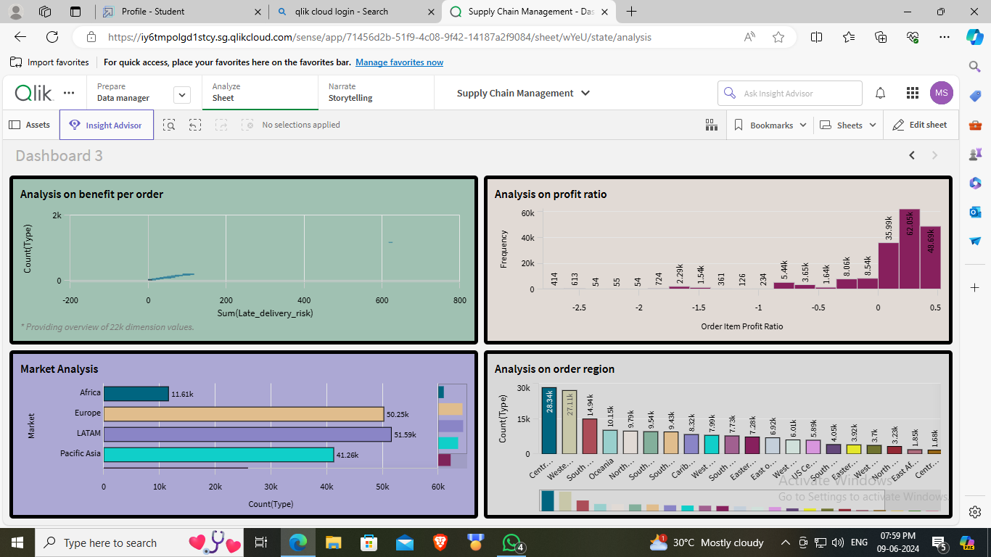

Dashboard 3

7. Report

7.1 Report Creation

A comprehensive report was created to summarize the findings and insights from the data analysis. The report includes:

- An overview of the business problem and objectives.

- Key visualizations and their interpretations.

- Recommendations based on the analysis.

- Potential areas for future improvement.

8. Performance Testing

8.1 Amount of Data Rendered

Performance testing was conducted to ensure the dashboards could handle large amounts of data without significant lag or delays. The tests confirmed that the system efficiently rendered large datasets.

8.2 Utilization of Data Filters

Data filters were utilized to allow users to focus on specific subsets of data. Performance tests showed that applying filters did not significantly impact the speed or responsiveness of the dashboards.